Name: Hansen Wu

Laboratory 1

Introduction to MARS and MIPS

Computer Science 10

NOTE: shaded sections of the exercises are questions which you must answer as part of your lab report.

In this lab, you will be introduced to the MARS programming environment in which you will develop MIPS assembly language programs. It can be downloaded from:

http://courses.missouristate.edu/KenVollmar/MARS/

Basic MARS Use

1. Download and launch MARS on your computer. You will see something like this screenshot:
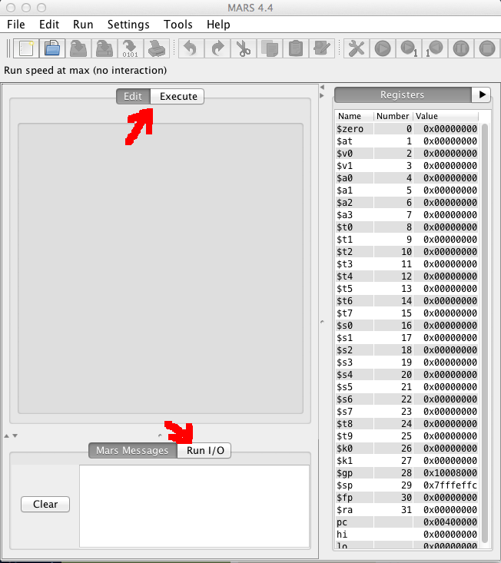
Notice the Edit/Execute tabs and the Mars Messages/Run I/O tabs. These are used to switch between the panels used for those purposes.

Also notice the Registers panel along the right-hand side of the screen. All 32 MIPS registers are labeled and numbered, in addition to 3 more listed at the bottom (the pc , or program counter, and hi and lo registers, which you will learn about later).

Which registers have a non-zero value at this point?

The following are non-zero: $gp, $sp, and pc.

Explain what the value of the pc indicates:

It seems to indicate the current memory address that the program is looking at. Before running any part of the program, it appears to start at 0x00400000. This is also the address of the first line of code in the “Text Segment” window. This value changes according to the address that the program is currently on.

Exercise 1:

2. In MARS, Under File select New and Copy the lab1program.doc text that I posted in Course Studio and past it (using the paste icon in the MARS command bar) into the Edit panel.

3. Use File…Save As to save as lab1.asm, a MIPS program that adds two numbers, similar to the one you will see in the lecture.

NOTE: (All icons have menubar equivalents; the remainder of these steps will use the icon whenever possible.) 4. Assemble the program using the icon  (also available from the Run menu).

Examine the Mars Messages panel, and notice that the message indicates the assembly was successful (hopefully).

Also notice that the tab automatically changes from Edit to Execute, and that the Text Segment and Data Segment panels are now displayed (similar to the earlier screenshot).

What does the 0x notation mean which precedes the 8-digit numbers you see displayed in these panels?

It's part of hexadecimal notation to precede the number with "0x".
5. The Text Segment contains the code from the .text section of the program (the program instructions). Explain what you think each column in this panel is used for:

Bkpt:
Short for breakpoint, this pauses the program when it reaches the checked line. It appears unable to stop at the first line in the example program.

Address:
The address pointing to the code in memory.

Code:
The code that is stored at that memory address.

Basic:
Short summary of what the line of code does.

Source:
A copy of the code with its line number appended.

6. What is the starting address of the program?

The first line of code is given the address 0x00400000.

7. The Data Segment contains the code from the .data section of the program (the variables and constants defined in the program). What is the starting address of the Data Segment?

The initial address is 0x10010000.

8. Each row in the Data Segment lists the contents of 8 words in memory, each of which contains 32 bits, or 4 bytes, of data. Notice that the first 7 words in the Data Segment contain non-zero values. Why are these non-zero for this program?

They are storing the strings that were created for the program, "prompt_string" and "result_string".

9. Use the Settings menu to configure the MARS displays. The settings will be retained for the next MARS session.
- The Labels display contains the addresses of the assembly code statements with a label, but the default is to not show this display. Select the checkbox from the Settings menu. 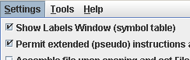
- Select the checkbox to allow pseudo-instructions (programmer-friendly instruction substitutions and shorthand).
- Select the startup display format of addresses and values to be hexadecimal.

10. Use the slider bar to change the run speed to 1 instruction per second. 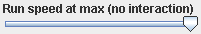 This allows us to “watch the action” instead of the assembly program finishing directly.

11. There are a number of ways to execute the program:

- The  icon runs the program to completion. Using this icon, you should observe the yellow highlight showing the program’s progress in the Text Segment, and green highlight showing the registers being modified in the Registers panel. When there are changes to the Data Segment, they are also highlighted.
- The  icon resets the program and simulator to initial values. Memory contents are those specified within the program, and register contents are generally zero.
- The  icon is “single-step.” Its complement is , “single-step backwards” (undoes each operation).

12. Run the program to completion, using the very slow 1 second per instruction speed. You will need to enter values twice in the Run I/O panel, to be used for the addition. Upon completion, the following will be displayed:
Enter a value:2
Enter a value:3
The sum is:5
program is finished running –

13. Reset and run the program one instruction at a time, using the single-step . Examine the registers after each instruction to verify that you understand any new values.

14. Set a breakpoint at address 0x400030 by clicking on the checkbox at the left of the instruction.

- Reset and run the program again, the program stops at the breakpoint, before executing the instruction.
- Examine the value of $t3 at this point. What is it? _________
- Perform a single step is to execute the add instruction.
- Examine the value of $t3 again. What is it now? __________
- Click to continue from the breakpoint. Note that you could modify register or memory values directly at a breakpoint before continuing, if it was necessary to do so for testing purposes.

15. Open the Help  for information on MIPS instructions, pseudoinstructions, directives, and syscalls.

Exercise 2: Now that you have seen the basic operation of MARS, try and write your own program! Modify the add program so that it prompts you for your name and age, and outputs a message that greets you and tells you how old you will be in 4 years.

# to read in a string, do the following. The string will be stored in memory at location “answer”
li $v0,8 # system code for read string
la $a0,answer #put address of answer string in $a0
lw $a1,alength #put length of string in $a1
syscall

#you also need the following definitions in your .data section for this to work:
answer: .space 51 #will hold up to 50 characters, so the name must be 50 characters or less

alength: .word 50

When you run your program, your console should look like the following:

What is your name? Harry Potter
What is your age? 11

Hello, Harry Potter
You will be 15 years old in four years

Format and comment your program appropriately in MARS. Email this program to me.

# Name
li $v0, 4 # Print prompt
la $a0, namePrompt_string
syscall
li $v0, 8 # Get user string input
la $a0, nameInput_string
lw $a1, inputLength
syscall

# Age
li $v0, 4 # Print prompt
la $a0, agePrompt_string
syscall
li $v0, 5 # Get user integer input
syscall
move $t0, $v0
addi $t0, $t0, 4 # Process new age by adding 4

# Print user info
li $v0, 4 # Hello
la $a0, nameResponse_string
syscall
li $v0, 4 # Name
la $a0, nameInput_string
syscall
li $v0, 4 # You'll be
la $a0, ageResponse_front_string
syscall
li $v0, 1 # Age
move $a0, $t0
syscall
li $v0, 4 # years old
la $a0, ageResponse_back_string
syscall

.data
namePrompt_string: .asciiz "What is your name? "
agePrompt_string: .asciiz "What is your age? "
nameResponse_string: .asciiz "Hello, "
ageResponse_front_string: .asciiz "You will be "
ageResponse_back_string: .asciiz " years old in four years"

nameInput_string: .space 51
inputLength: .word 50

When you need to print the output of a program (for an assignment, for example), hit the Prnt Scrn key on your keyboard. This puts the screen in a Copy Buffer, which you can then paste into a Word document and print.

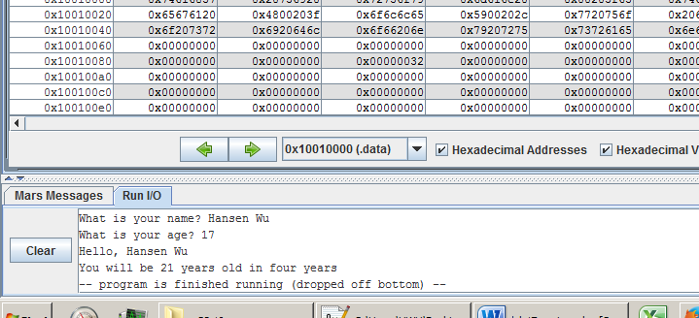
Exercise 3: Begin editing a source file for a new MIPS program.

1. Type in the following program (you don’t have to type the #comments), and save as lab1-2.asm.

.text
.globl main

main: li $v0,4 #load sys call code for print string to $v0 (contract for syscall)
la $a0,prompt #address of string to print
syscall #print the string

li $v0,1 #sys call for print integer
lb $a0,val #load the integer to print to$a0 (contract for syscall)
syscall #print it

addi $t0,$t0,1 #increment the value of $t0

li $v0,10 #sys call for exit
syscall

.data
prompt: .asciiz “your code is: “
val: .byte 8

Assemble the program. If you have typed the program in with no syntax errors, the Mars Messages window Ashould tell that your program loaded successfully. Run the program to observe its simple output.

2. Examine the Data Segment. Record the values shown for the first 16 bytes in data memory (write exactly as shown in the MARS data segment, where 4 bytes are grouped together in each entry):

Data Segment
Address Value (+0) Value (+4) Value (+8) Value (+C)
0x1001000 0x72756F79 0x646F6320 0x73692065 0x0020203A
3. Record the address and data contents of each byte location in the Data Segment using the stack model of memory.

- Show one byte per row.
- Lowest address should be at bottom of stack.
- Label the address which corresponds to the start of the prompt string
- Label the address which corresponds to val (NOTE: the Labels panel lists the addresses).

Address Label | Data
0x10010010 val  0x1001000F  0x1001000E  0x1001000D  0x1001000C  0x1001000B  0x1001000A  0x10010009  0x10010008  0x10010007  0x10010006  0x10010005  0x10010004  0x10010003  0x10010002  0x10010001  0x10010000 prompt | 79 | What is the meaning of the first byte that has a 00 value?  That byte is null, which comes at the end of a null-terminated string to signal that the string has ended.  Where does the value of 08 come from in the byte with that value?  In the code, it's the very last line that creates a byte called "val" with a value of 8.
  08
  00
  20
  20
  3A
  73
  69
  20
  65
  64
  6f
  63
  20
  72
  75
  6F

Exercise 4:
1. Create another source file containing the following program, and save it as lab1-3.asm:

.text
.globl main

main: li $v0,10 #sys call for exit
syscall

.data
nums: .byte 4,3,2,1
.half 8,7,6,5
.word 1,2,3,4
.space 1
.word 12
letters: .asciiz “EFG”
.ascii “efg”
neg1s: .byte -1,-1
.word 15

2. Before running the program, predict the contents of data memory (use hexadecimal values, but to save space, omit preceding the numbers with 0x):

Data Segment
Address Value (+0) Value (+4) Value (+8) Value (+C) Value (+10) Value (+14) Value (+18) Value (+1C)
0x10010000 01020304 00070008 00050006 00000001 00000002 00000003 00000004 00000000

0x10010020 0000000C 00474645 FF676665 000000FF 0000000F

3. Record the address and data contents of the Data Segment using the stack model of memory.

- This time, show one word (4 bytes) per row.
- Lowest address should be at bottom of stack.
- Label the addresses corresponding to nums and letters.
- Mark the byte with the address neg1s by shading that cell with a color.

Address Label | Data
0x10010030  0x1001002C  0x10010028  0x10010024 letters  0x10010020  0x1001001c  0x10010018  0x10010014  0x10010010  0x1001000C  0x10010008  0x10010004  0x10010000 nums
  00 | 00 | 00 | 0F
  00 | 00 | 00 | FF
  FF | 67 | 66 | 65
  00 | 47 | 46 | 45
  00 | 00 | 00 | 0C
  00 | 00 | 00 | 00
  00 | 00 | 00 | 04
  00 | 00 | 00 | 03
  00 | 00 | 00 | 02
  00 | 00 | 00 | 01
  00 | 05 | 00 | 06
  00 | 07 | 00 | 08
  01 | 02 | 03 | 04

Assemble the program, and examine the Data Segment/verify that the data is stored in memory as you predicted.
Exercise 5: Consider the following program (you don’t need to create a new source file, just read the code and answer the questions):

.text

la $s0,neg1byte
la $s1,oneword
la $s2,twowords
la $s3,smallstring
lb $t0,3($s1)
add $s1,$s1,$t0
lb $t1,0($s1)
addi $s1,$s1,2
add $s2,$s1,$t1
sb $t0,0($s2)
addi $s1,$s1,7
add $a0,$s1,$t0
li $v0,4
syscall
lw $t0,0($s3)
sh $t0,-5($s2)
li $v0,10
syscall

.data
neg1byte: .byte -1

oneword: .word 0x02030405

twowords: .word 02,03

smallstring: .asciiz “abc”

halfwords: .half 10,11,12,13,14,15

Assume that neg1byte represents address 0x10010000, and that all unspecified bytes in memory contain 00.

1. How many bytes are allocated in the data section, from the starting address neg1byte to the end of the data stored at halfwords (count any extra bytes allocated by the data directives)?

In total, eight words are used. Each word contains 4 bytes. Therefore, a total of 32 bytes are allocated.

List your predicted values for the bytes stored in the Data Segment before the program executes:

Data Segment
Address Value (+0) Value (+4) Value (+8) Value (+C) Value (+10) Value (+14) Value (+18) Value (+1C)
0x10010000 0x000000FF 0x02030405 0x00000002 0x00000003 0x00636261 0x000B000A 0x000D000C 0x000F000E

2. Fill in the following table to show the contents of registers $s0-s3 and $t0-$t1 after each instruction is executed.

Only fill in the entries that change for each instruction. If a value stored in memory is modified by an instruction, also record that address and its new value on that line. Assume all registers contain a value of 0 initially!

$s0 $s1 $s2 $s3 $t0 $t1 $a0 addr: val

la $s0,neg1byte 0x10010000

la $s1,oneword 0x10010004

la $s2,twowords 0x10010008

la $s3,smallstring 0x10010010

lb $t0,3($s1) 0x00000002

add $s1,$s1,$t0 0x10010006

lb $t1,0($s1) 0x00000003

addi $s1,$s1,2 0x10010008

add $s2,$s1,$t1 0x1001000B

sb $t0,0($s2)

addi $s1,$s1,7 0x1001000F

add $a0,$s1,$t0 0x10010011

li $v0,4
syscall

lw $t0,0($s3) 0x00636261

sh $t0,-5($s2)

What should be displayed in the Run I/O window at the end of the program?

bc

Record your predicted values of the bytes stored in the data section after the program is done executing (just record the new values in memory, in the correct location; don’t rewrite your whole table):

Data Segment
Address Value (+0) Value (+4) Value (+8) Value (+C) Value (+10) Value (+14) Value (+18) Value (+1C)
0x10010000 0x000000FF 0x61620405 0x02000002 0x00000003 0x00636261 0x000B000A 0x000D000C 0x000F000E

